Store Build SOP

Version 0.1
Date: 12 Nov 2025

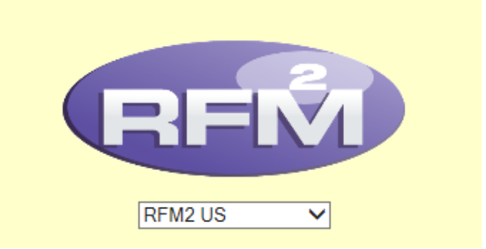

Revision History and Version Table
Version no. | Version Description | Author/Date | Reviewers/  Date | Approving Party/ Date
0.1 | Revised SOP of Store Build | Sanjeev  11/13/25 | Muskan T 11/13/25 | 11/13/25
1.0 | HM toy MI's update for 2026 | Sanjeev  01/08/26 | Muskan T 01/08/26 | 01/08/26
2.0 | Feature Update | Muskan T  26/03/26 | Muskan T  26/03/26 | 26/03/26
3.0 | Cashout thold Value Update | Sanjeev  28/04/26 | Muskan T  28/04/26 | 28/03/26
4.0 | Menu Item Set Update | Muskan T  16-07-26 | Muskan T  16-07-26 | 16-07-26

McDonald’s Restaurant Build Process

Store Build SOP 1
Revision History and Version Table 1
Objective 4
Introduction 4
1. Scope of the Document 4
2. Step by Step Procedures 5
2.1 RFM 2 Login 5
2.2 Profile Setup 5
2.3 Store Build Tab Flow and Guidelines 8
2.4 Receipt, Tax & Routing Tab: 10
2.5 Feature Assignment Tab 12
2.6 Operations Details Tab: 13
2.7 Menu Item/POS/Pricing Tab: 17
2.7.1 Alternate Ordering: 19
2.7.2 Menu Type Assignment: 19
2.8 ASSIGN PRICE LIST TO RESTAURANT 20
2.9 Tax 25
2.10 Menu Item Activation 27
2.11 BLM Comparison 29
2.12. POS Layout 30
2.13 User Access 32
2.14 Make the store is active and changes are saved. 33
2.15 Package Generation and Testing: - 33
2.16 Completion Email: - 34
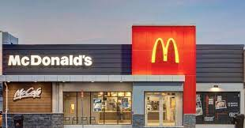

Objective
The document contains detailed information on the control requirements and operating procedures necessary to successfully initiate and complete the restaurant build process in RFM 2.

Introduction
Store build is a request that comes from Operations Technology Manager (OTM) for a new store. Requests are received through a survey or a competent person as well. OTM always sends in a request for a store build using a predefined form. i.e click here to fill Store build survey

For example: In the below images you will see that we have received a new store request for NSN #39361
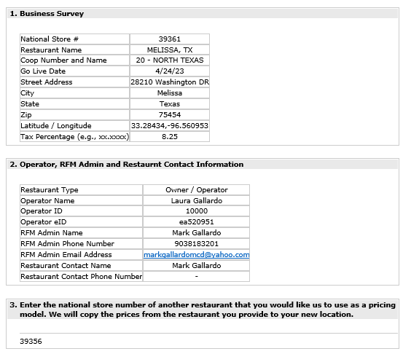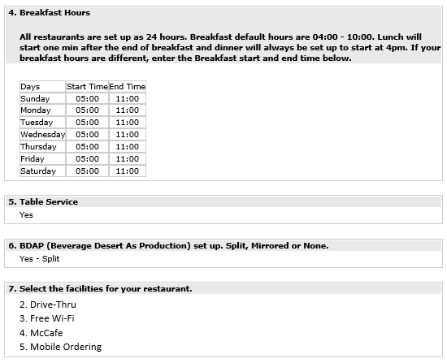

Scope of the Document

This document outlines the procedures used at present. This may change down the line and should be revised for changes.
The examples used in the document are for illustration purpose only.
NOTE:
- Collect all the information from Store build survey received for building a new store.

- Check for BDAP (Beverages and Dessert as production) from the store build survey.
- If BDAP is YES, check whether the store should be configured as BDAP – Mirrored or Split.

Step by Step Procedures

2.1 RFM 2 Login

- Use the RFM website link mentioned below to login to RFM.
- RFM website link: https://rfm.mcd.com

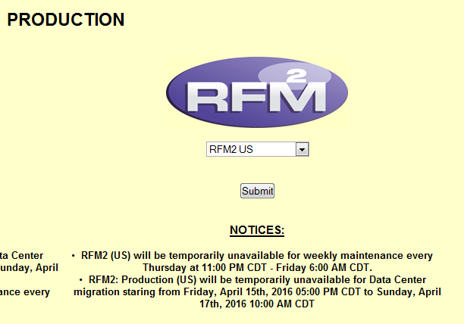

- Choose the Productions instance RFM 2 US, click on submit and it will take you to the RFM homepage.

2.2 Profile Setup

- RFM2 US à Admin Tab à

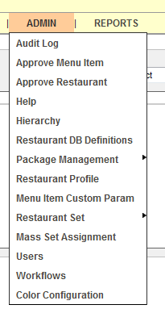

- Restaurant Profileà
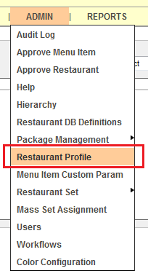

- New Restaurant à

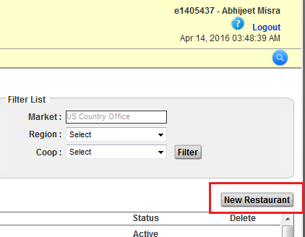

- Select Manual Restaurant as given below.

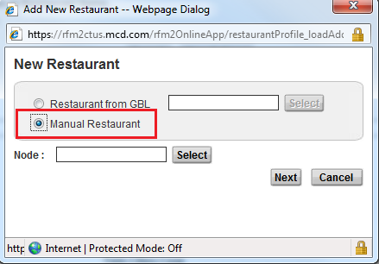

- To select Node, click on Select (as shown in the below screenshot).

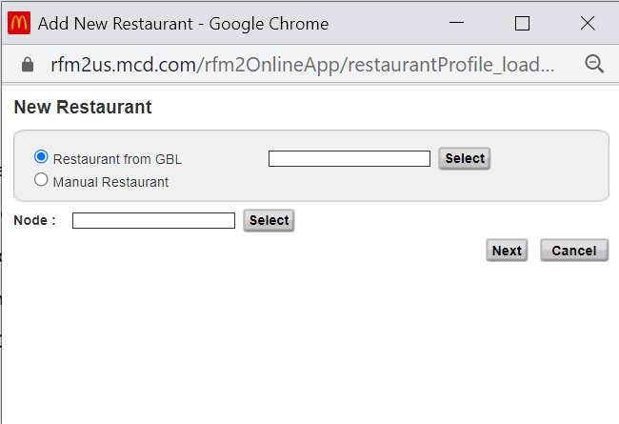

And choose the hierarchy (Click on + sign to expand before the region in which store needs to be created)
Select CoOp à Click on Next.

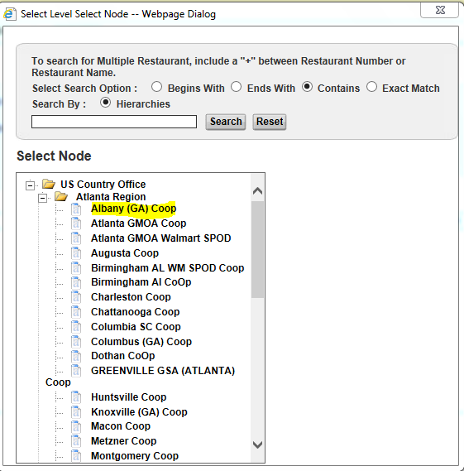

2.3 Store Build Tab Flow and Guidelines

Address Tab:

Fill all the information collected from store build in the Address tab.

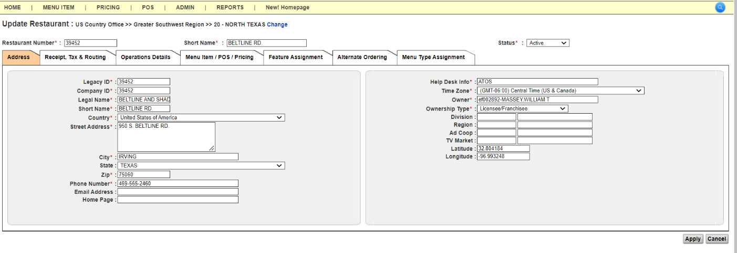

 | Fields | Default Value if Location Manager has no information
Street Address | Restaurant ID | As per the request Survey
Street Address | Legacy ID | Same as Store number
Street Address | Company ID | Same as Store number
Street Address | Legal Name | As per the request Survey. (Same as restaurant name)
Street Address | Short Name | As per the request Survey. (Same as restaurant name)
Street Address | Country | United States of America
Street Address | Street Address | As per the request Survey
Street Address | City | As per the request Survey
Street Address | State | As per the request Survey
Street Address | Zip | As per the request Survey
Street Address | Phone | As per the request survey (Restaurant Contact Phone Number)
Street Address | Help Desk Info | ATOS
Street Address | Time Zone | GMT-6 (if not available use US & Canada Time zone)
Street Address | Latitude | As per the request survey
Street Address | Longitude | As per the request survey
Street Address | Owner Name | Search the O/O with eID mentioned in the survey received in case of Licensee/Franchisee stores.  And write McDonalds in case of McOpCo store.  (Make sure eID exists in LDAP otherwise it must be added by raising ticket via support team)
Street Address | Owner Type | Select as appropriate, either “McOpCo” or “Licensee/Franchisee” as per the information provided in the store build Survey
Street Address | Status | Leave it as “Inactive”

Note: ( if in survey sheet latitude and longitude is not available then take confirmation from STIM.)

2.4 Receipt, Tax & Routing Tab:
Default Receipt Header | BUY ONE GET ONE FREE QUARTER POUNDER  W/CHEESE OR EGG MCMUFFIN  Go to www.mcdvoice.com within 7 days  and tell us about your visit.  Validation Code: ______________  Expires 30 days after receipt date.  Valid at participating US McDonald's.
Default Receipt Footer | McDonald's Restaurant
Welcome Message | Keep it blank

Routing Mode = Dynamic (Routing is always flexible)
Production Routing Set = Standard
Presentation Routing Set = Standard
POS Version = Choose the last available in drop down
Facilities = As per the request survey
In Sell points: Select Delivery, Mobile, Drive through, CSO, Front Counter

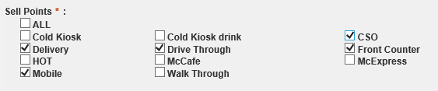

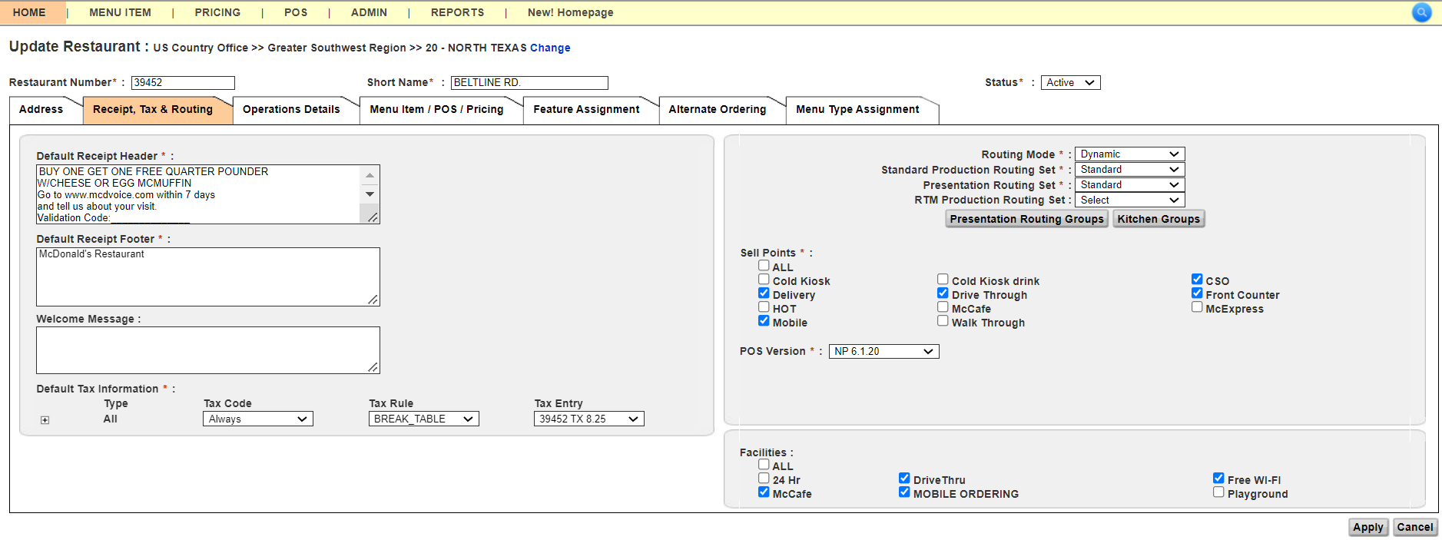

**Default Tax Information à Keep it Blank (You need fill it after Tax Code is created)

EXCEPTION SCENARIO: OHIO TAXES

Please keep in mind the following points while working on Ohio Stores:
There are 3 Tax scenarios:
• Eatin
• Takeout
• Others
For OHIO Licensee Stores
Only Eatin must be taxed and Takeout & Other must set to Never. However, all the Carbonated Sugar Drinks must be taxed ‘Always’ whether Eatin, Takeout or Other. This is how the Ohio Store Entity Profile screen looks like -
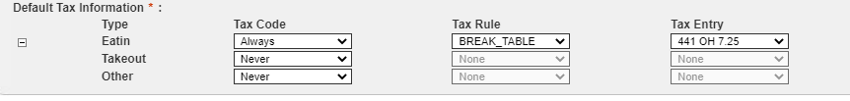

Please make sure store tax is set to always for stores that are in Kentucky State even though they are part of Ohio region.
2.5 Feature Assignment Tab:
- Keep below features in the Assigned section.

Mobile Offers | SP8 - Default
Spanish Pilot | Default
SP10.4_Loyalty_Kiosk | CSO Userinterface
POS UserInterface | Gift Cards
Password Management | SP8 - NGK
Cashless | SP7.0
Kiosk Lunch Hours | TableService
SP10.1_Loyalty | RouteOrders
SMART Grill | Non CYT Hours
SP8.5 - MO Table service | QR14
Dual Point | CSO EFTMedia
LifeOfTLOG | Sales Tax
SP6.5 | Discount/Promo
SP11_KioskMealOverlay | SP9-Kiosk6
SP10.8_Consolidated_Button | Kiosk Breakfast Hours
SP11.4_Dynamic_QR_code_Receipt | GlobalSolution_Simplified_STLD
SP12_CardlessRefund_OriginatingCard | SP11_Optimized Ordering_PDP
Enable_DiscountForNon_Products | 40mm grill slips

Total = 36 Features

2.6 Operations Details Tab:
Select US country set for the following:
Business Limits,
Discounts,
Coupons sets, - must be customized as per reference store.

      - Business limits
      - Coupons
      - Export options
      - Localization
      - Tax Definition
      - Customizable Parameter
      - Tender type

As per the Reference store update:
- Day part
- Discount
- Dimension Name – Medium First
- Customizable Parameter - EVM Unbundling for stores under New York (New Hampshire)

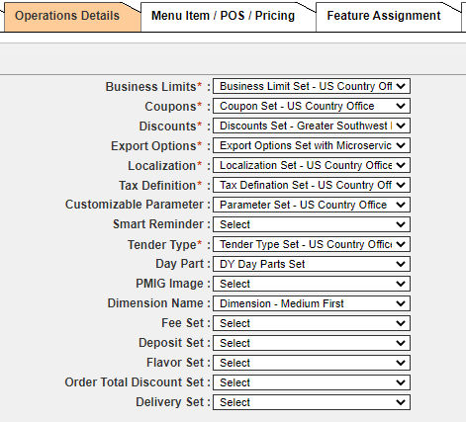
- Operations Details Tab: Any fields marked as "Yes" in the reference store under the Operations Details tab should also be updated in the new store.
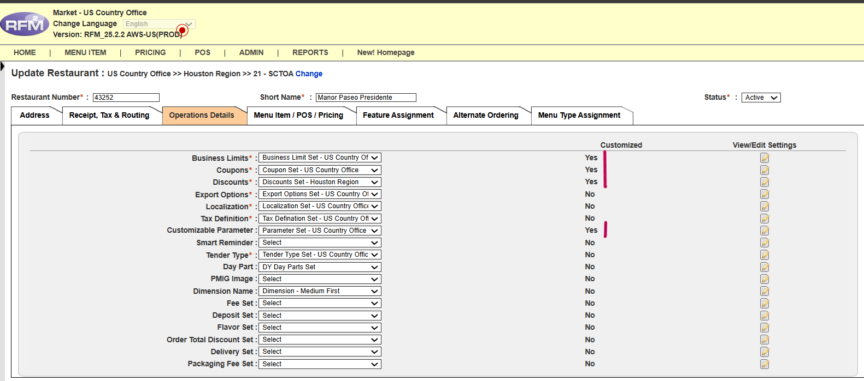

- In Customizable Parameter
In Cashless :- Update as per the reference store. (You can open one more RFM instance and open the reference store for quick reference)

Cashout_thold = Parameters - Gift Card Cashout Threshold
MaxNoOfDaysToSAF = Parameters - Max # of Days to SAF
MaxSAFDollarAmount = Parameters - Max SAF Amount Limit
StandInLimit = Parameters - Auth. Not Available Limit
CashlessSignLimit = Signature Limit

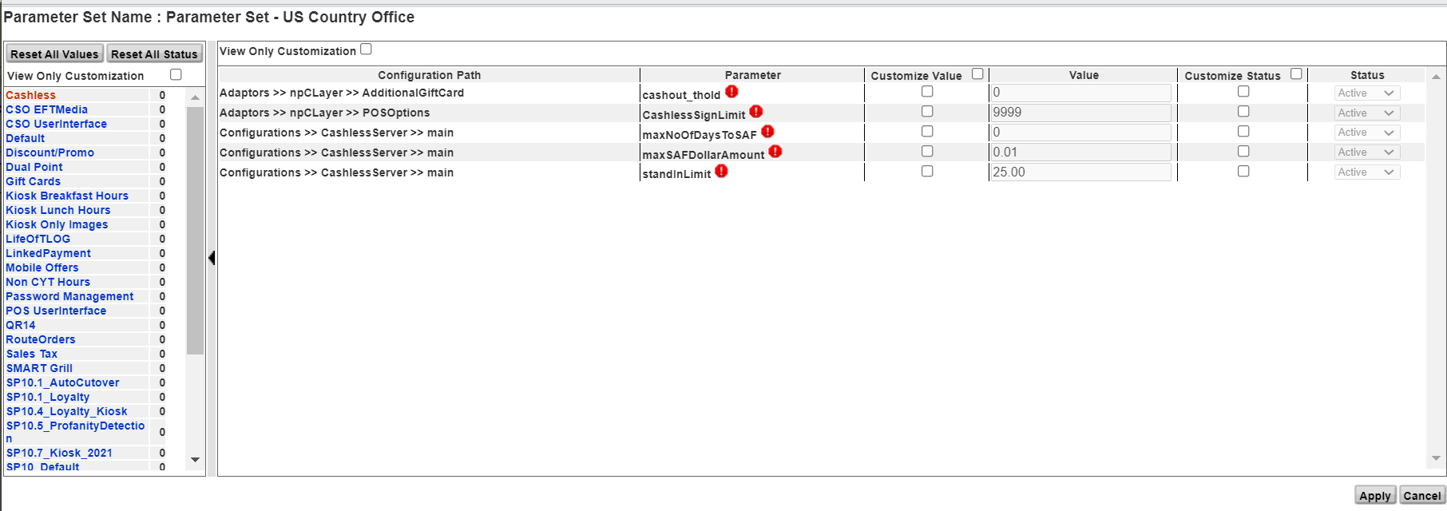
Update the Cashout Threshold (Cashout_thold) value when creating any new restaurant.
For any other state the value should be 0. If not, we must put down this process ASAP.
Note: Cashout Threshold value of Gift Card to $14.99 for the California stores
We must check State not Region in the address tab of Restaurant Profile.
State Code | State Name | Statutory Cash Out Threshold
CA | California | 14.99
CO | Colorado | 5
CT | Connecticut | 2.99
MA | Massachusetts | 5
ME | Maine | 4.99
MT | Montana | 4.99
NJ | New Jersey | 5
OR | Oregon | 4.99
RI | Rhode Island | 0.99
TX | Texas | 2.49
VT | Vermont | 0.99
WA | Washington | 4.99
HI | Hawaii | 4.99

- Update Kiosk Breakfast hours, Kiosk Lunch hours & SP9-Kiosk 6 as per the Survey received.

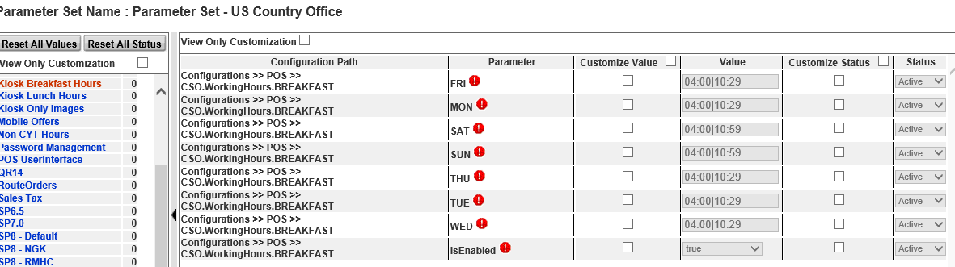

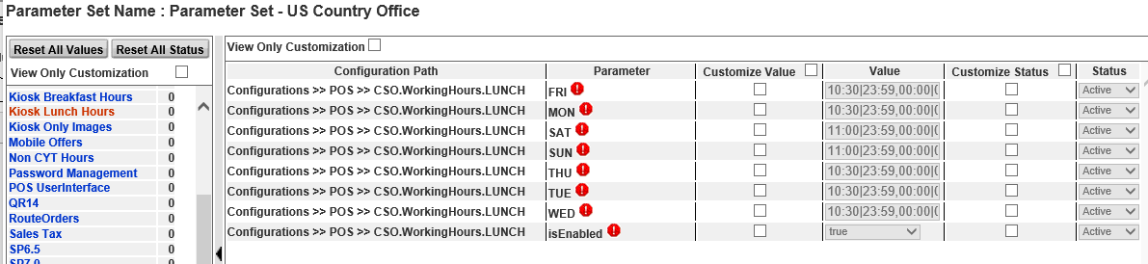

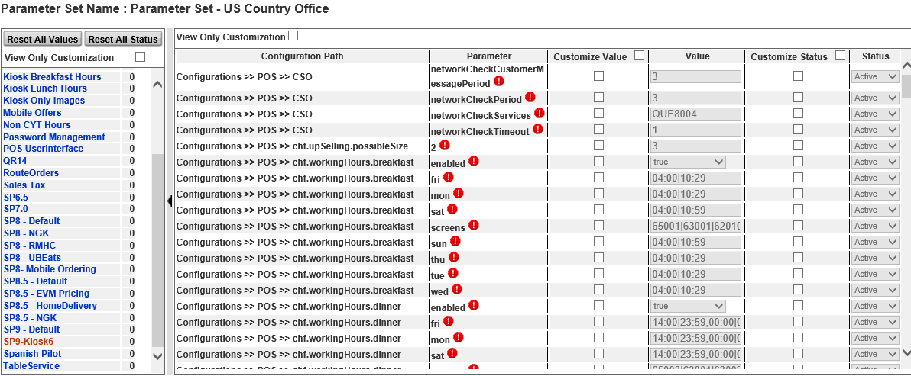

Keep it unchecked if it is unchecked in reference store.

2.7 Menu Item/POS/Pricing Tab: “Menu item and POS only”
- Menu Items under Choose Set Type:
- Select Menu Item and two sets must be selected with the sequence (Country & Coop).
- Select the BDAP set as per the survey (Split).
- kindly ensure that the new Display Order Code Menu Item Set is assigned at the bottom of the menu item set.

Note:
- Always assign New BDAP Split set from now onwards.
- Please cancel the validation report pop out always.
- kindly ensure that the new Display Order Code Menu Item Set is assigned at the bottom of the menu item set.

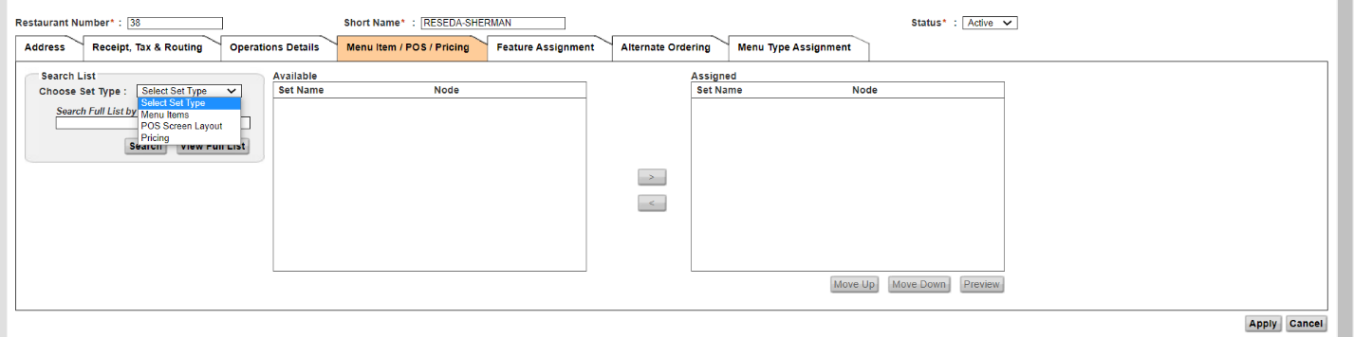

Updated Screenshot:

- If a store is in the state of “OREGON” please make sure to assign the
Menu Item Set - Bottle Deposit and Auto Selection.

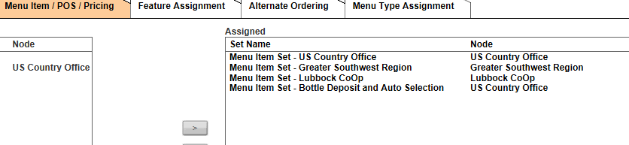

• POS Screen Layout: HQ level screen set for that CoOp should be added.

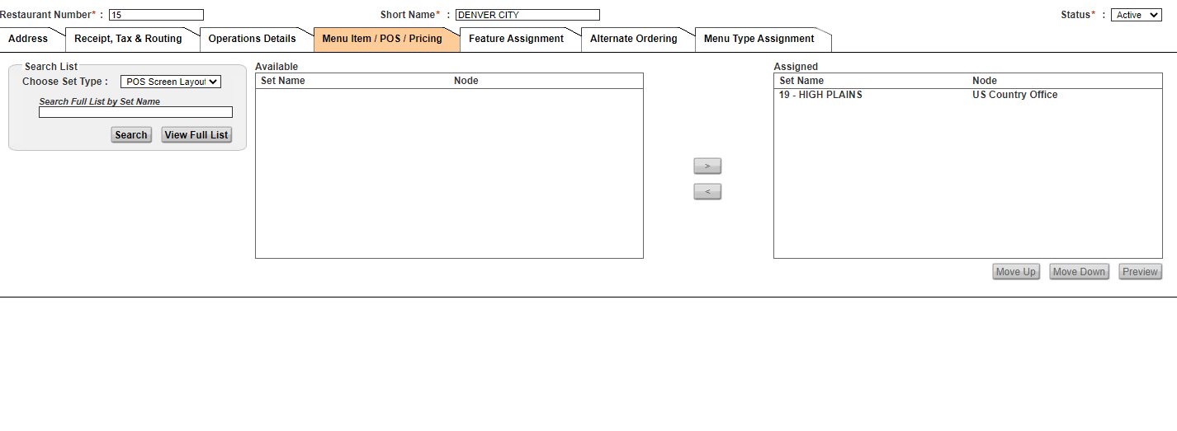

2.7.1 Alternate Ordering:
- This Tab remains untouched if it is not updated for Reference store.
- Select relevant option for Present Area by clicking on drop down.
- Update Store hours as per the reference Store.
- Update Drive Thru, Lobby, Curbside, Delivery etc as per the reference store.

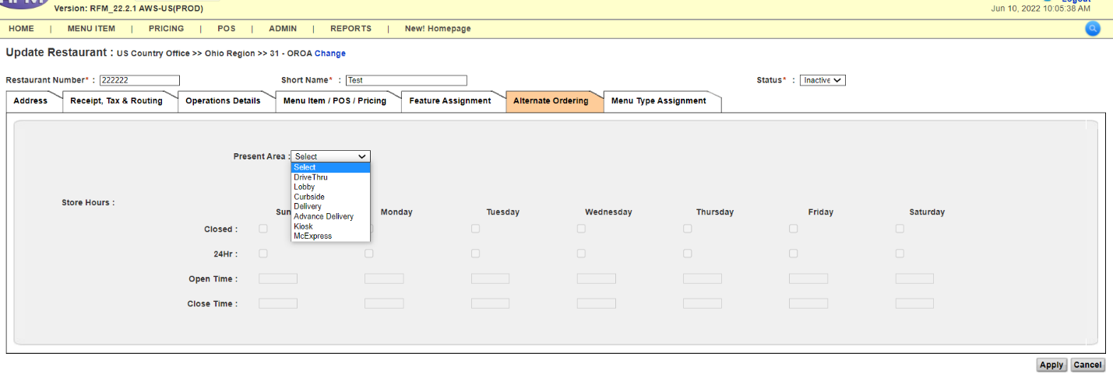

2.7.2 Menu Type Assignment:

- This Tab remains untouched if it is not updated for Reference store.
- Update service hours as per the Reference Store.

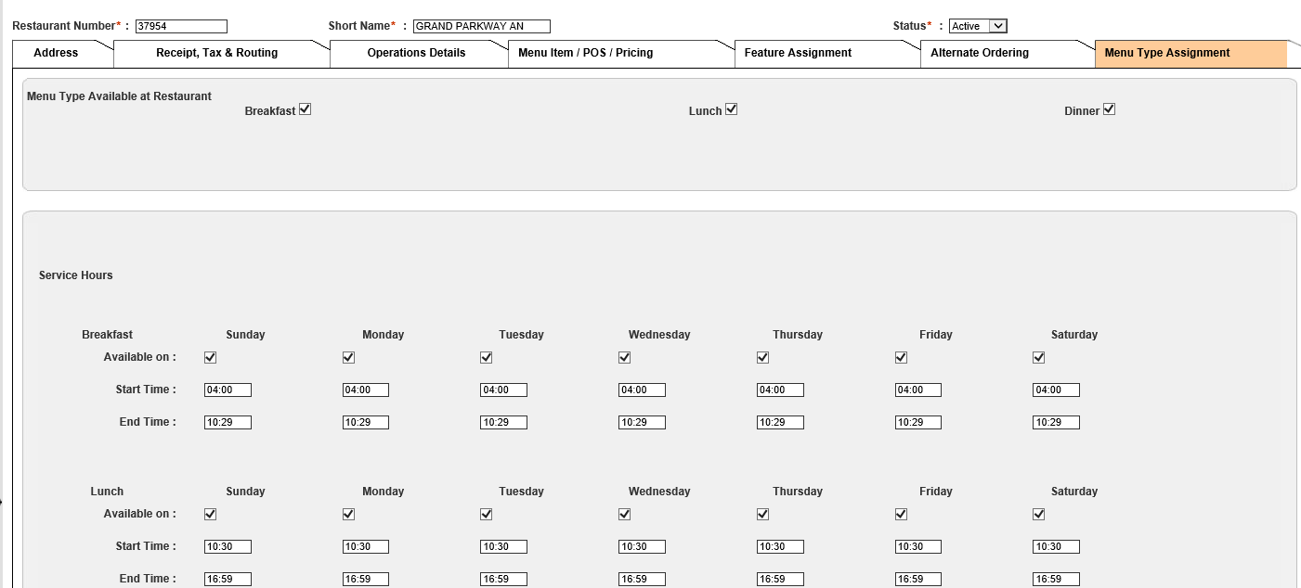

2.8 ASSIGN PRICE LIST TO RESTAURANT

Creation
- Go to Pricing Price Sets.

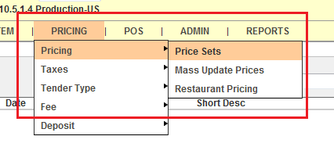

- Click on “New Price Set”

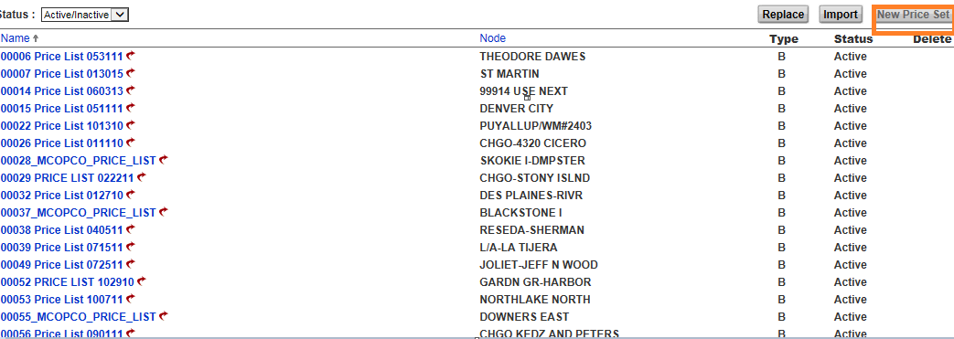

- Update the Price Set Name in the format: [Store No. Price List MMDDYY]
eg.11223 Price List 061517.
- Update the Price Set Name for the McOpCo stores in this format: [Store No._MCOPCO_PRICE_LIST]
eg.11223_MCOPCO_PRICE_LIST.
- Select the Node which is the new store number and also in Copy Price Set, select the reference store number (copy price store).
- Click on Next to create new price set for the store.

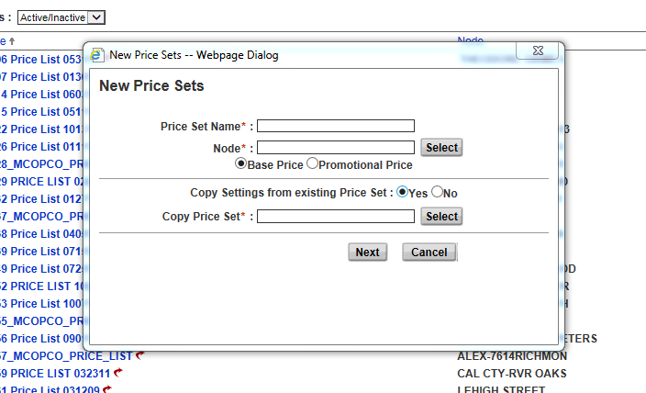

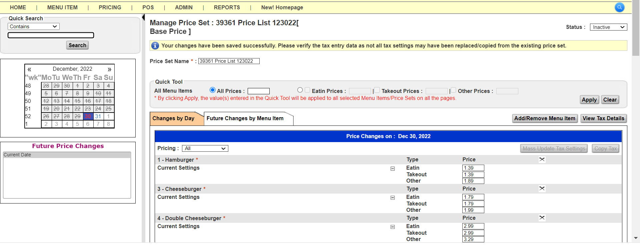
Now click on View tax details >
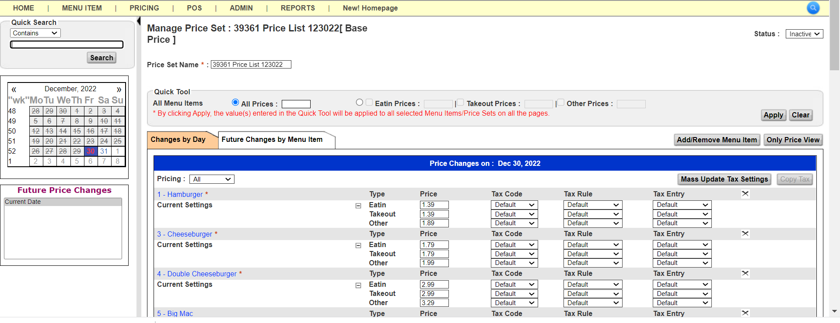
Click on Mass Update Tax setting and select Default for all options
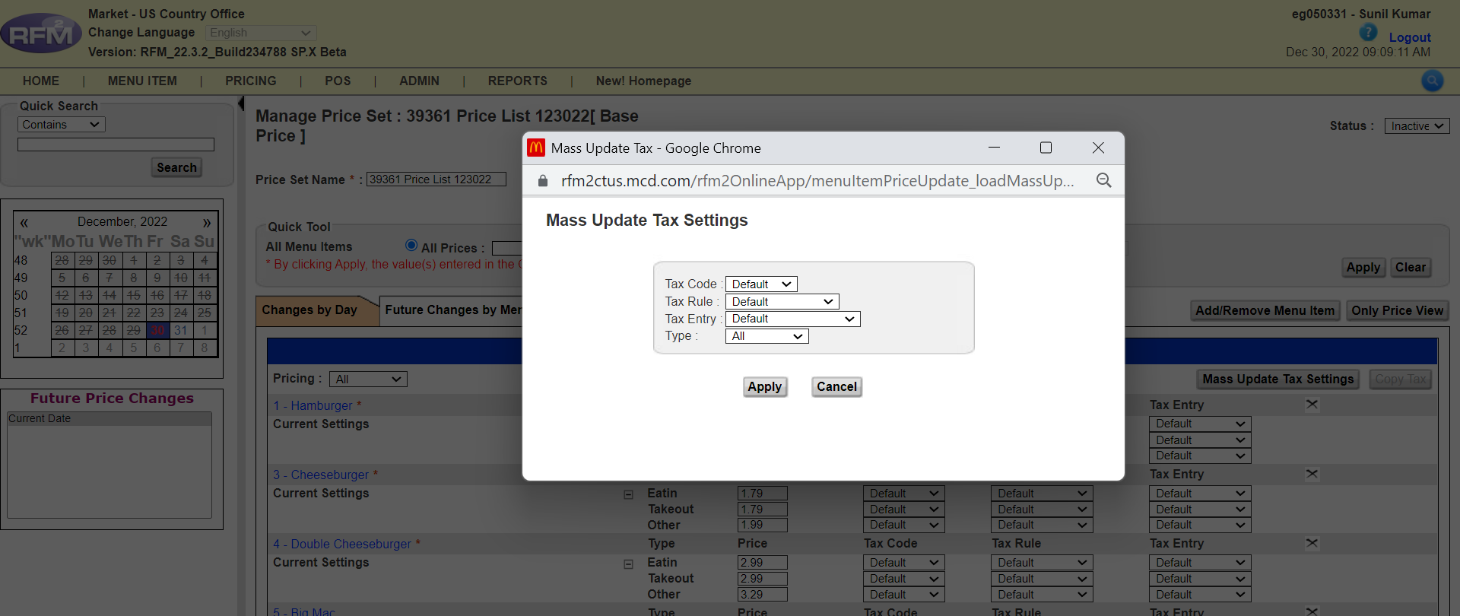

Click Apply >
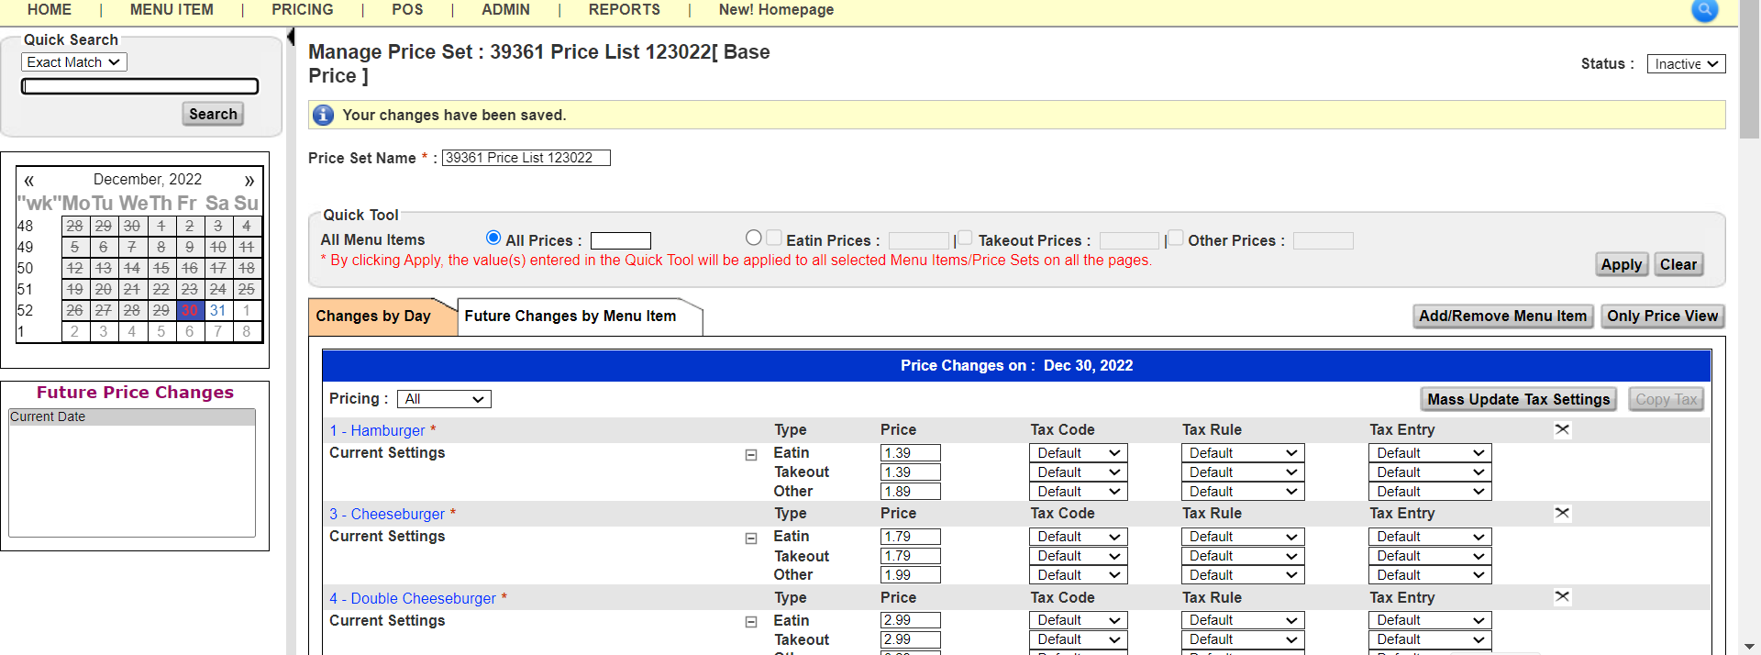
One more important aspect is that Tax never applies to Gift items, so now go to quick search tool select exact match and paste the string for gift items:
Arch
Gift
Heart
USA Today
Local Fundraiser
(These are the MI #: 936+937+8315+8053+8056+8346+8347+8487+8460+8461+8492+8493+8494+8495+8496+8497+8498+8499+8072+8476+8475+10396+10397+10398)

Select Exact Match & Click search >
`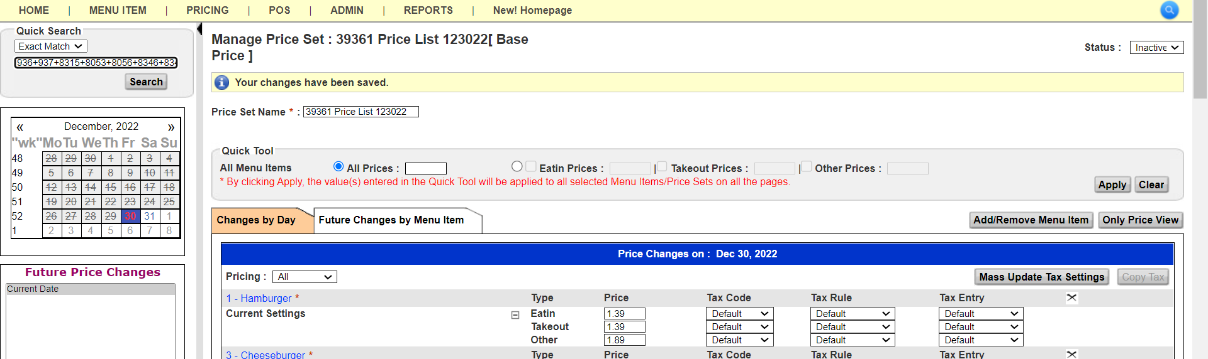
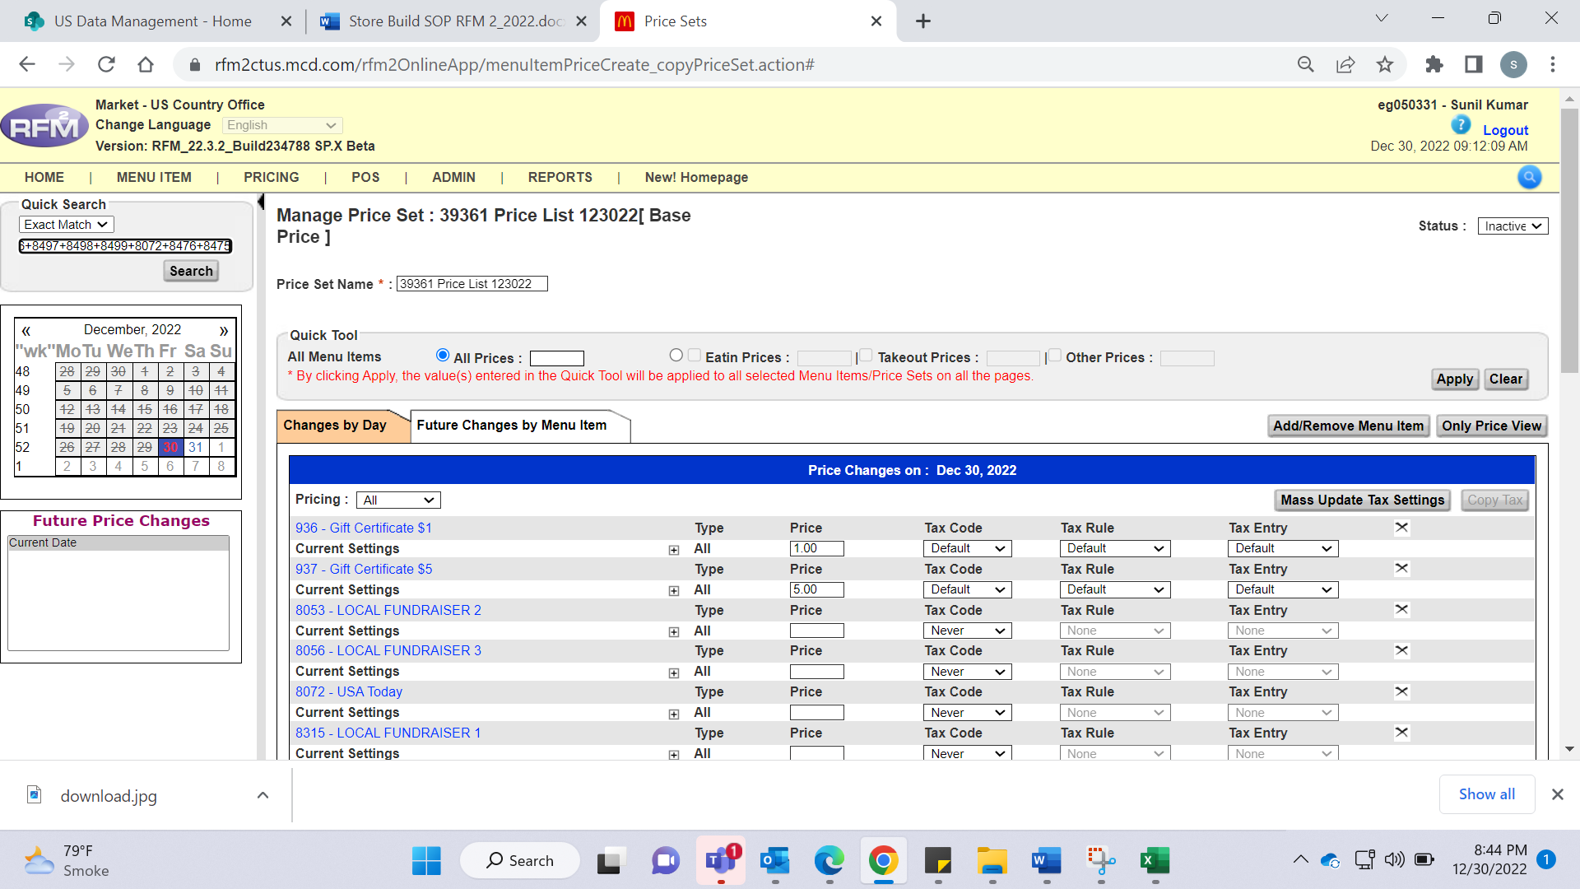

Click Mass Update tax Settings >
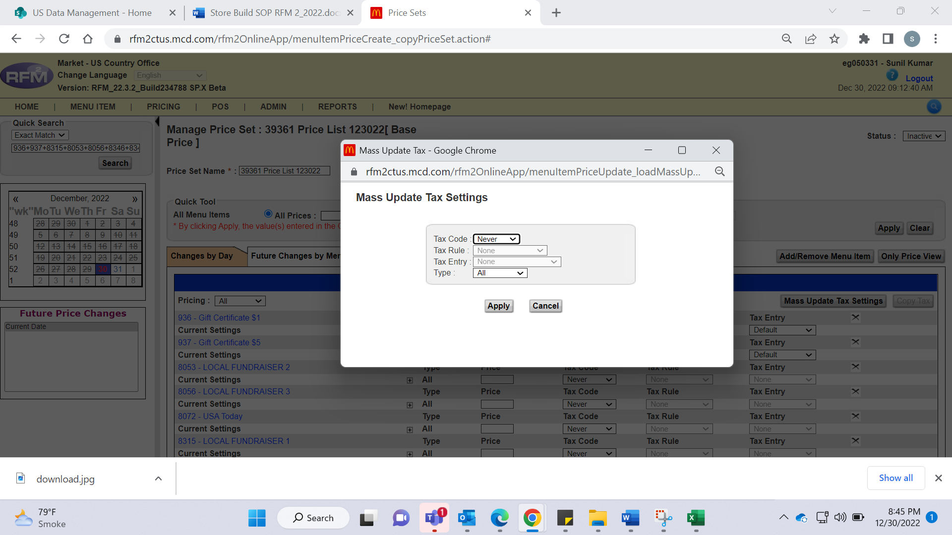

Select Never in Tax code and click Apply
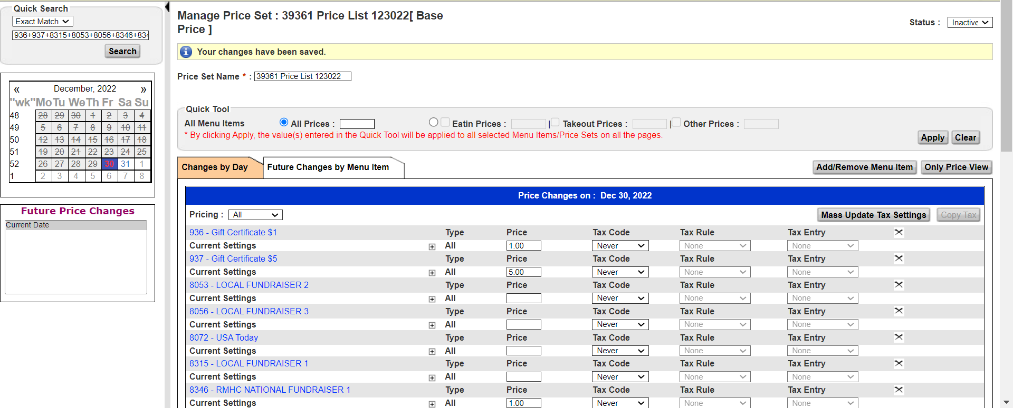

Assigning at Store:

• RFM2 - Admin - Restaurant Profile – Menu Item / POS / Pricing Tab - Search List - Choose Pricing from drop down – Enter Store Number - Select the Price set - move it to Assigned area – Apply – Save

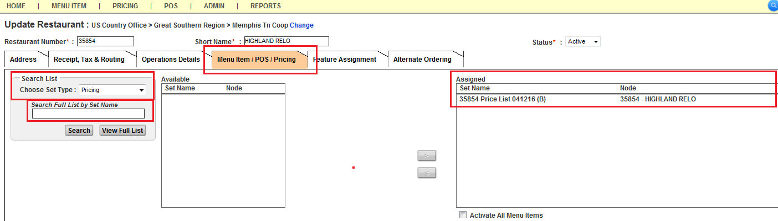

2.9 Tax
• Go to Pricing - Taxes - Tax Type - search with tax rate (say 7.6) - out of all the options, look which one matches exact requirement (go inside the link and see Tax Break Table - match and see all in Start column - whichever matches your requirement)

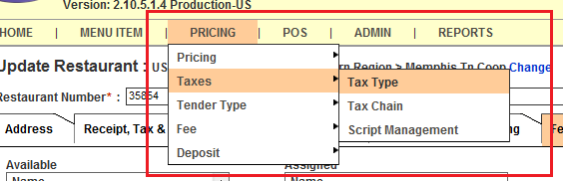

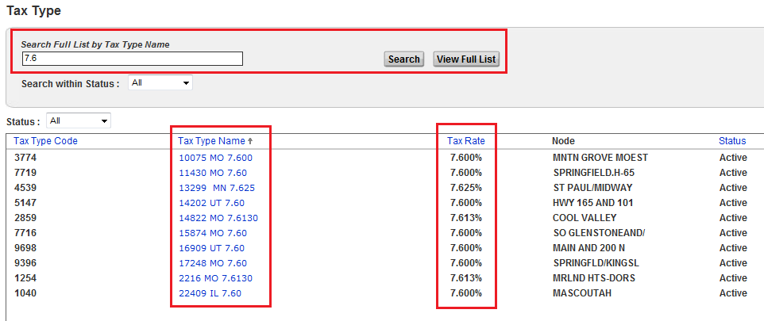
Search by reference store number instead of Tax rate and create the same tax for new store.

- While choosing the tax rate of any store which has the same tax rate as for our new store, please validate if all 4 tax types are created for the store which your choosing). As per the attached screenshot.

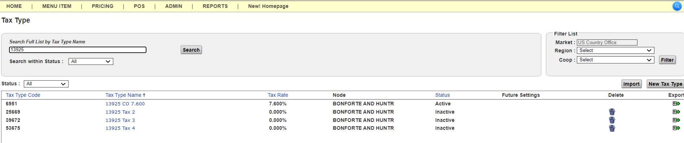

- Copy the same Tax Type Name - New Tax Type - Enter the copied name to Copy Settings from Existing Tax Type, Tax Type name:
- Should be in this format = [Store number State Code Tax Rate]
(Example – 12345 MO 7.6)
- Node: Choose the new store which you are building.
- Apply Changes and make it active.

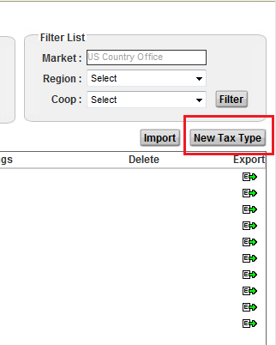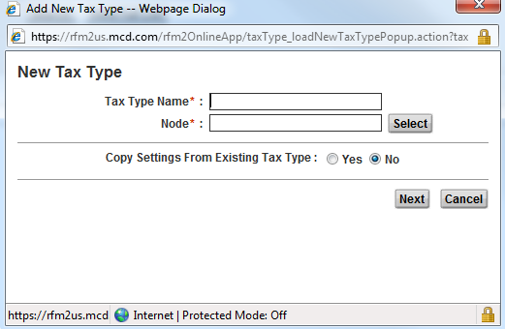
Make sure whenever a new Tax Type is created, update & validate tax rate value for new store as per survey received and delete the tax break table (which also got copied over while creating).
- Follow the same steps as above to assign Tax 2, Tax 3 and Tax 4.
- Come back to Restaurant Profile - Tax tab - Enter details in Default Tax Information
- Apply the Changes.

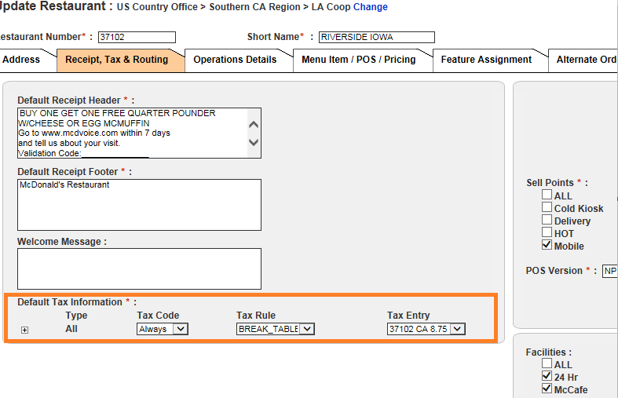

2.10 Menu Item Activation
- Go to Reference store and Pull the Menu Item Activation Report by selecting the Menu Item and clicking on preview button.
- Save the CSV file.

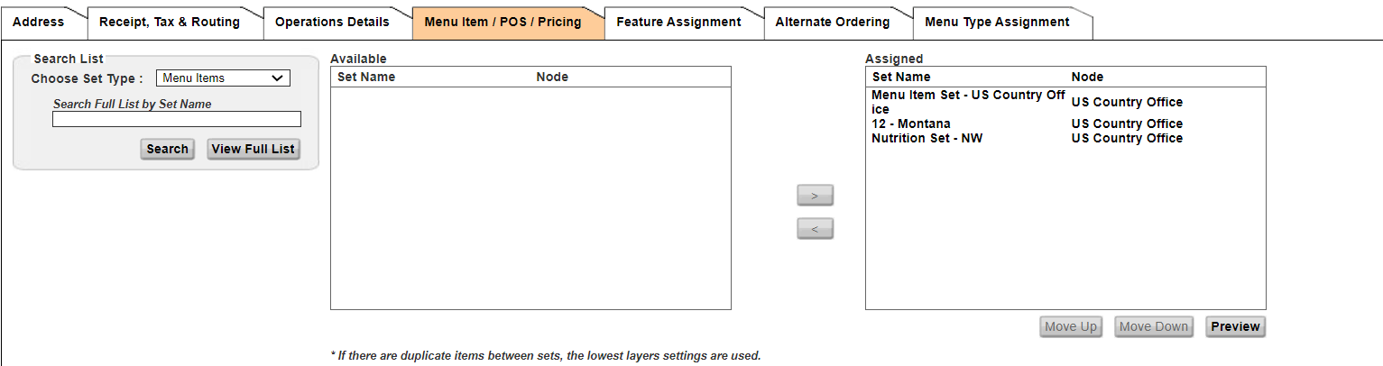

- Once you get the list copy the menu items in an excel sheet. Filter the active Menu items.
- Go to Mass Status Update as shown below.

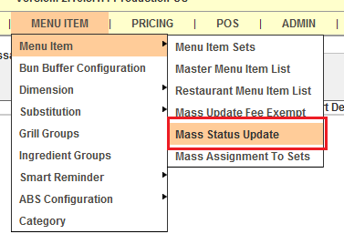

- Search the string of the Menu Items with exact match and move them to right side and click Next.
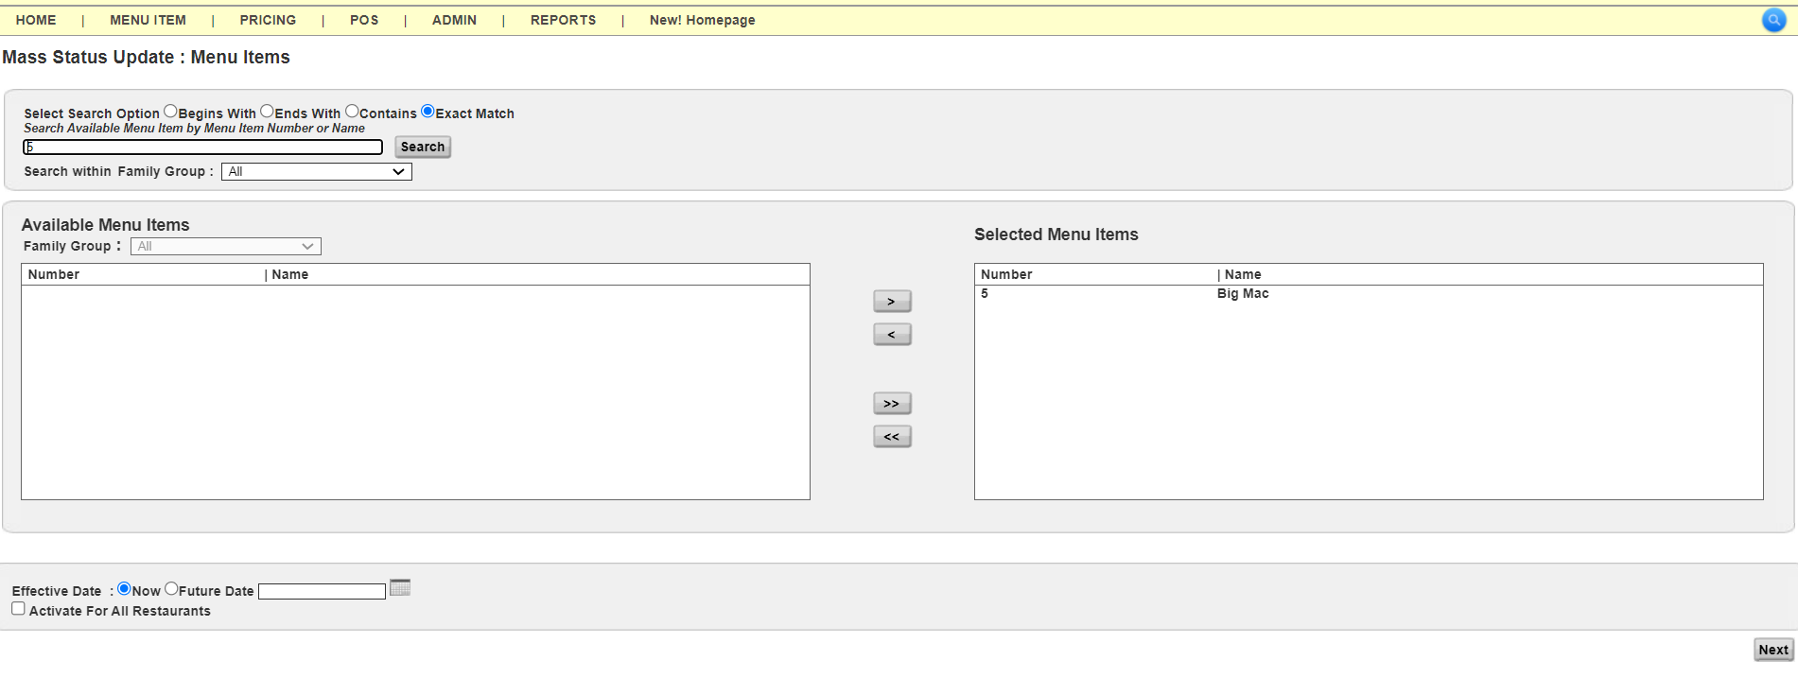
- Now Search the New Store Number and move it to the right side and click Next.

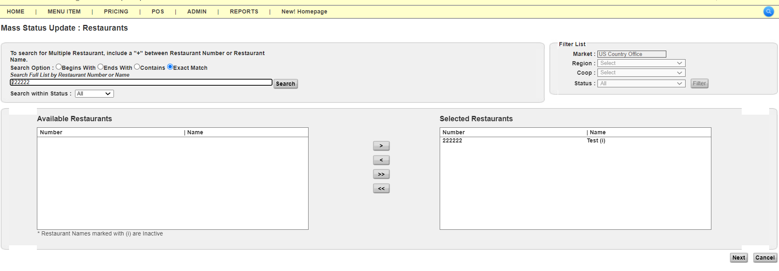
- Check the Menu Items as per the below screenshot and Save changes.

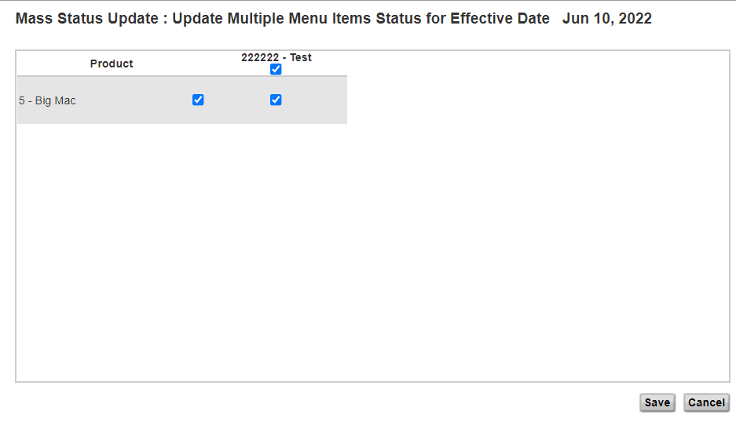
- Follow the same steps while activating all of the Menu Items.
- Once activated all Menu Items, pull out another report from the new store and re-activate the remaining Menu Items.

Important! – PTA Upcoming Happy Meal Toys for whole year for new store
HM Toy for 2026 –
25632+25633+25634+25635+25636+25637+25638+25639+25640+25641+25642
**Note: Activation can be done for only 20 Menu Items at a time using string tool.

2.11 BLM Comparison

- Generate BLM report of Reference store and replicate the changes for the New Store.
- Generate the BLM report for reference store. (Reports>POS Layout>BLM Assignment)
- **Please note that after assigning store level keys, please do the BLM comparison as well.

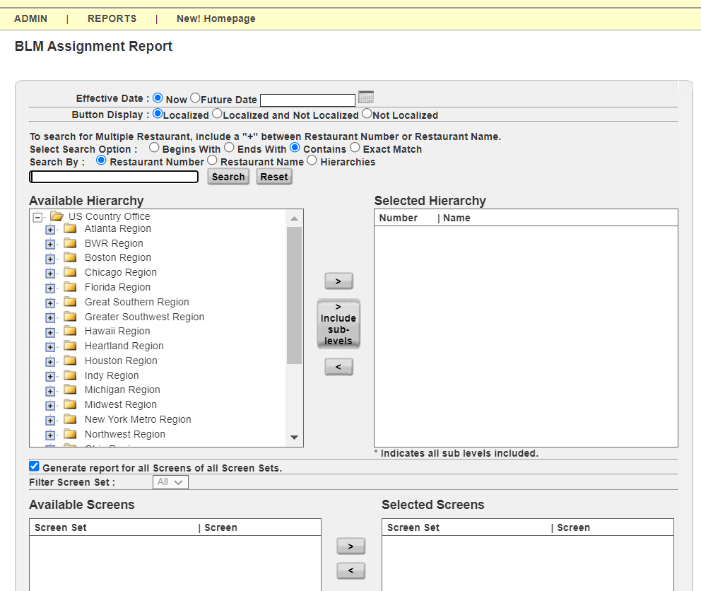

2.12. POS Layout
Perform the store level localization as per the Reference store using the BLM report.
- POS>POS Layout>Select Node>Search Store

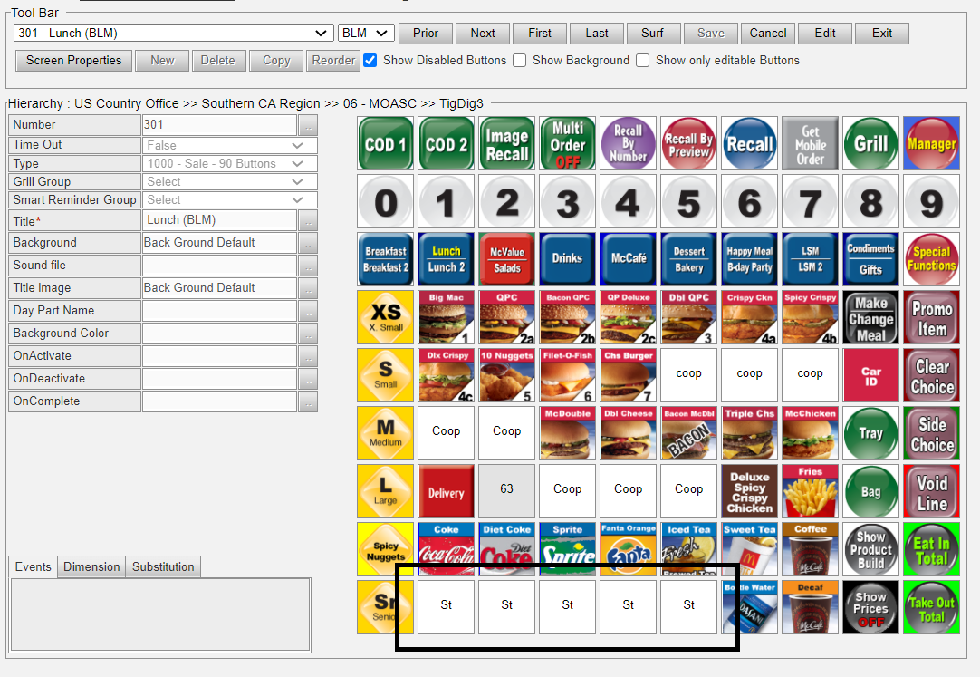
For example:
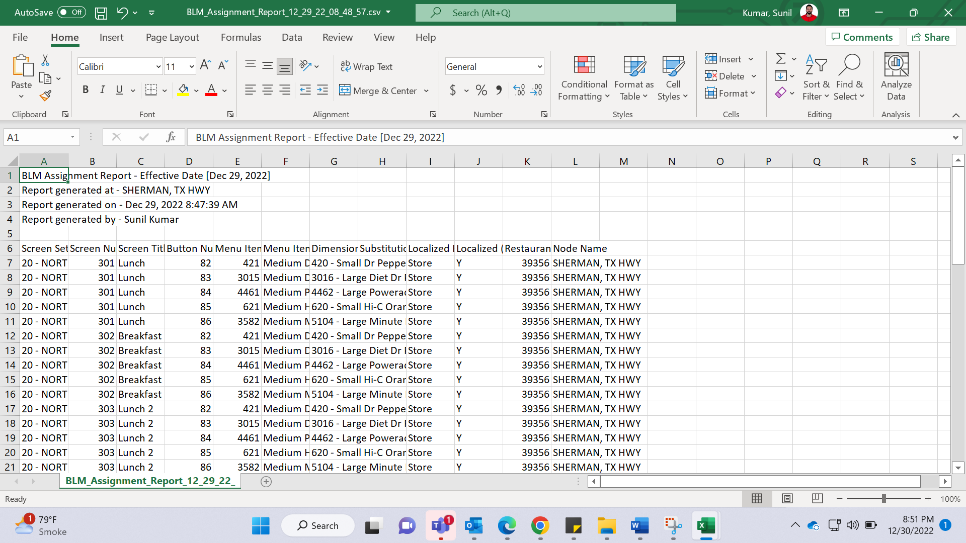
Localize the button number 82 for screen 301 by assigning MI 421
Go to screen 301 in the tool bar > select button number 82 > click edit > localize – yes > Menu item number > search for MI 421 > select > save.

2.13 User Access
Make sure to provide access to Store Owner when the store is built.
ik876erI878944
- Go to Admin à Users

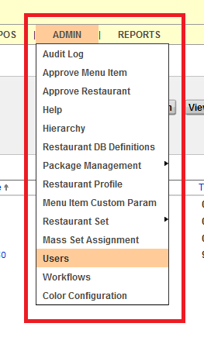

- Search the Owner by User ID, First Name or Last Name

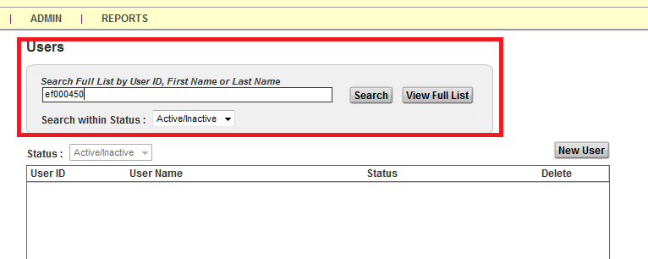

- Search for the Store in Available Hierarchy Selections and move it to the Assigned Hierarchy Selections.

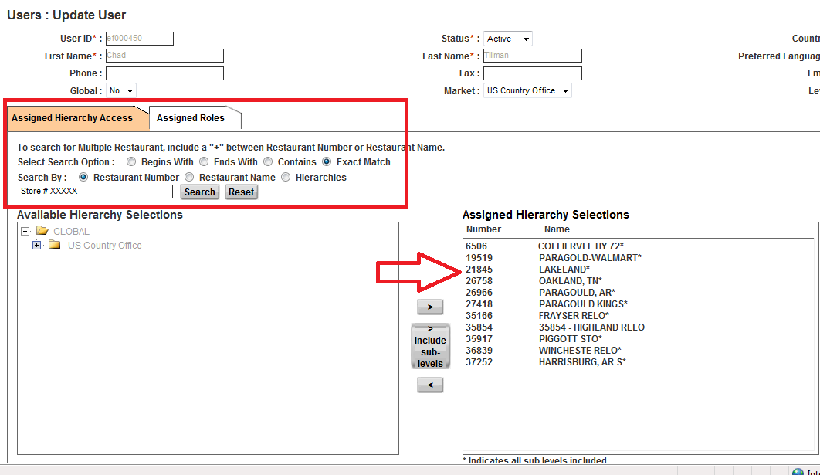

** Note: For McOpCo Store - All the below 4 McOpco Admins should be given access to the store.

em015013 | Ferreira-Martinez Ana
EM085059 | Bonczyk Mark
em080014 | Brad Reid
e0002090 | Savitsky Kathleen

2.14 Make the store is active and changes are saved.
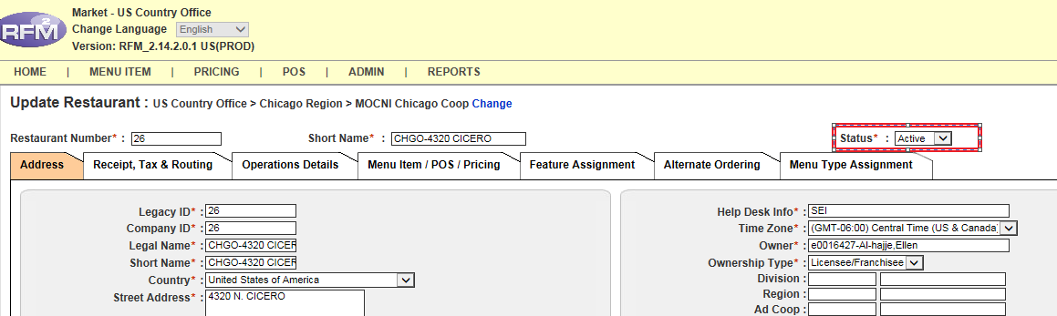

2.15 Package Generation and Testing: -
Pull out the package and test it whether everything is working fine or not.
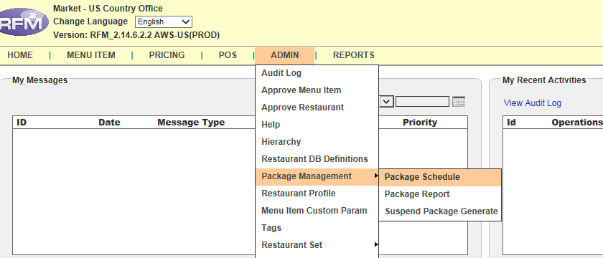

- Pull the Non-RIDM package for the store and test it on the laptop load.
ADMIN -> Package Management -> New Package Schedule -> Adhoc Schedule

- Check the radio button for “Packages with messages and file output” and then search the store and move it to right side box. Click on Save.
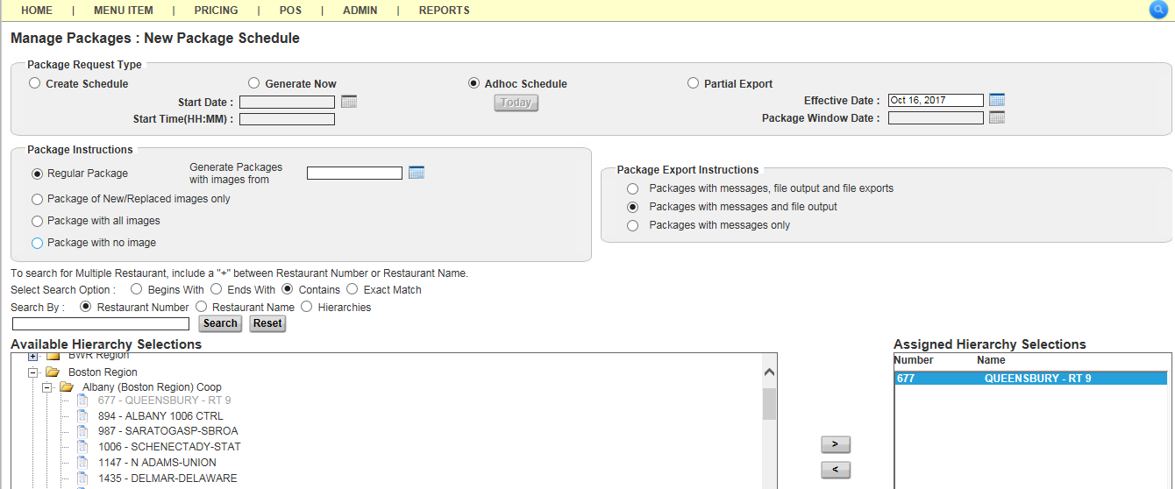

- Test all the store level keys by ringing it on laptop load.

2.16 Completion Email: -
- Send one completion email to Coops’ SITM for the store that has been created in RFM.
(While delivering the store attach –
- Store Survey
- Latest GAM file
- RFM screenshot (Displaying store active status)
Note: In case of McOpCo store builds deliver store to McOpCo Managers
- Mark Bonczyk Mark.Bonczyk@us.mcd.com & Juan Leon Juan.Leon@us.mcd.com

- Send one email to US-L3RFM Team (US-L3RFM@us.mcd.com).

- Send one email to SMART Team (smart@havi.com) for adding WRIN number for BDAP.

- Store Build Checklist Attached:

** NOTE: -
Assign below 2 ABC features to new store build post-store open date on next coming Monday (for go live Wednesday).
Example: If go live date of the new store is 18th June 2025 (Wed) then assign ABC feature on 23rd June 2025 (Mon).
- ABC feature (SP10.4_ABC),
- ABC Cash drawer feature (SP11.6_Optimize_CashDrawerImpacts)

But before that kindly send communication to STIM on Fridays (post go-live date of store – given in survey) - Confirming if the Go-Live date is the same or delayed?
- If not delayed – Kindly assign both the features on coming Monday, and
- If delayed – Kindly set ABC reminder as per new Go-live date.

Reference completion email sent to STIM:
Hi [STIM Name],

We have completed the RFM2 set up of the following restaurant. We set up the restaurant based on the information received through the electronic survey. Also please find enclosed the GAM spec to add admin access for the restaurant. We have given access to the owner operator. However, no users will have access to the store in RFM until the Owner Operator requests access through GAM for anyone else, they want to have.

Store: 12345
Store (Owner Operator) – [New Operator Name]

All the beverage choices and menu items on store level keys are synced as per the reference pricing store. You can add, remove, or change the products of your choice on store level keys.
- Localize any store specific products on LSM 2, if you’re unable to find it on any other screen.
- Following needs to be checked under Restaurant Profile → Operation Details
  - Validate the Business Limits under
  - Validate the Coupons enablement and their prices.
  - Validate the Discount percentage and its enablement for different categories.
- Validate or customize what will print on the receipts (Header & Footer) under Restaurant Profile → Receipt, Tax & Routing
- Run the POS Layout Report to validate the position and screen of each product. It helps to find and remove un-necessary products from store level keys.
- Validate tax rate Restaurant Profile → Receipt, Tax & Routing

Note:
- We have used NSN#98765 as a reference store to copy the prices.
- We'll assign the ABC feature to this store on 27th Jan (Monday). Please let us know if there's any question or concern.

We have setup this store as BDAP Split as per the email received.

